**DEMO2002 W10 Tutorial**

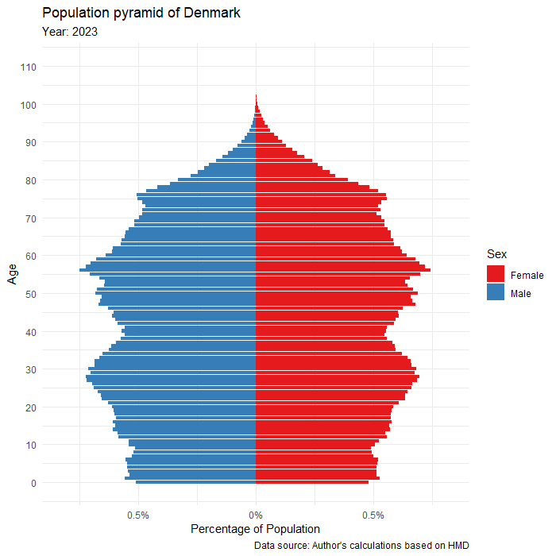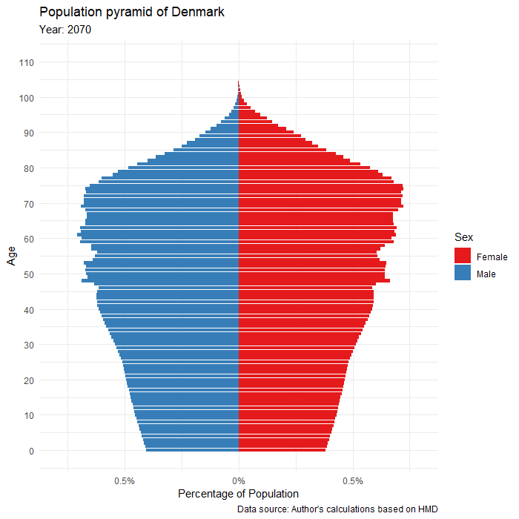

The above figure depicts population pyramids based on Denmark. The left is the population in 2023, the right is a projection in 2070.

The left figure of Denmark exhibits rather balanced proportions in a diamond-like shape. In 2023, there are bulges peaking around 30 years and 55 years. Despite this bulge within the working-age years, fertility appears to be in decline. In our projections, the fertility decline has shown up making a slimmer lower-half and narrower base in the 2070 figure.

By 2050, our projection shows a highly stabilized population (as opposed to the variation in 2023) due to simplified assumptions. We surmise that fluctuations in 2023 reflect variable amounts of immigration and policy over the years. Low mortality and low fertility have contributed to an aged population, as 2070 has significantly larger elderly cohorts compared to 2023. This makes for a sort of “inverted” pyramid in 2070.

In many developed countries today, migration is seen as the main pushback against ageing populations. In Nordic countries like Denmark, their populations would decline if not for migration. Heleniak and Sanchez Gaussen (2016) state that within reasonable figures, migration cannot halt population ageing nor maintain present existing age structures. In fact, the required numbers of migrants to do so would produce extreme stress on housing, labour, and welfare systems. This research concludes that migration can lower dependency ratios, and that policymakers should look to streamline their inclusion, particularly in providing aid for psychological barriers to socioeconomic integration.

**References**

Heleniak, T. and Sanchez Gaussen, N. (2016) *The impact of migration on projected population trends in Denmark, Finland, Iceland, Norway and Sweden: 2015–2080*. Nordregio.